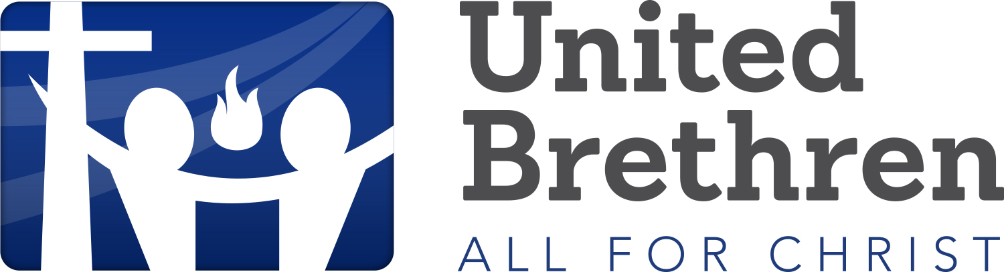
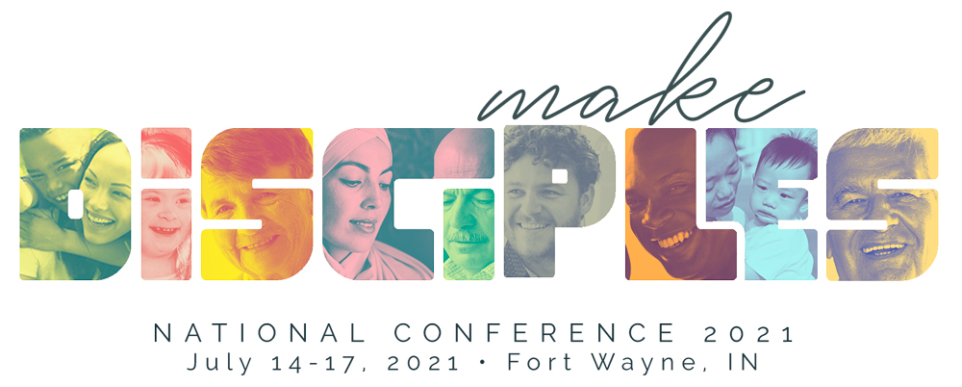

CHURCH OF THE UNITED BRETHREN IN CHRIST, USA

2021 NATIONAL CONFERENCE
The 2021 National Conference of the Church of the United Brethren in Christ, USA is a four-day event July 14-17, featuring worship services, workshops, church business, and children’s and youth activities held at Grand Wayne Fort Wayne In.
You are invited to partner with the Church of the United Brethren in Christ to showcase your ministry product or ministry to church staff and ministry leaders by exhibiting. Registration at the 2019 National Conference was approximately 1000.
Conference Information can be found at https://ub.org/events/nc/

EXHIBIT Opportunity
$500 per table
Each exhibiting organization will receive the following:
- 10’x10’ display Booth. 8’ high back drape with 3’ high side drape
- Choice of 6’ or 8’ draped display table, two chairs and a waste basket
- Complimentary WIFI
- Two exhibitor registrations for booth personnel – includes access to Worship Sessions
- Recognition in printed conference program
- Recognition and link on conference website
- Complimentary distribution of 1000 items in the conference bags
Exhibit tables will ring the exhibit hall.
Electricity is available for $25. If you require electricity, please let us know.
Exhibitor Hours

Wednesday July 14 Exhibitor move-in and set up Noon –5:30 pm
Exhibits open 5:00 pm – 6:30 pm
Reception with Exhibitors 8:00 pm – ??

Thursday July 15 Exhibits open during breakfast - Optional 7:00 am – 8:30am
Exhibits open 5:00 pm – 6:30 pm
Reception with Exhibitors 8:00 pm – ??
Exhibitors not holding a workshop may move-out following the Reception

Friday July 16 Exhibitor Workshops are available. 9:00 am – 12:00 pm
Please contact us for more information
Exhibitors move-out following the workshops.

For more information or to reserve exhibit space, please contact
Scott Graham at scott@excellentmeetings.com, 740-703-5762

SPONSORSHIP OPPORTUNITIES
Looking for additional ways to enhance your ministry’s presence and increase your brand visibility? Support the National Conference and connect with local church decision makers and influencers.
Become a National Conference Sponsor! Sponsorship opportunities can be customized just for you. Pricing varies.
Welcome Sponsor – Make sure every attendee sees your company or organization’s name or logo. As the Welcome Sponsor, you will be featured on signage at Registration.
Refreshment Break Sponsor – Give attendees a much-needed break as the Refreshment Break Sponsor. Your company or organization name or logo will appear on signage near the break table.
Evening Reception Sponsor - A sensational opportunity for your company to host a memorable evening after a busy day at the conference.
Lanyard Sponsor – Attendees will wear your company or organization name and/or logo around their necks throughout the conference. You will be the exclusive sponsor of custom-printed lanyards handed out during Registration.
Welcome Bag Sponsor – No conference would be complete without a cool bag to welcome its guests. As the Welcome Bag Sponsor, attendees will be presented at Registration with a bag displaying your company logo. It’s a sponsorship that will last beyond the National Conference.
Workshop Sponsor – Your logo will appear on a session slide, and your company or organization will be thanked by the workshop presenter. You will also have the opportunity to provide promotional giveaways, provided by sponsor, during session.

Sign up today
Sign up to exhibit or be a sponsor for the 2021 National Conference of the Church of the United Brethren in Christ, USA today!
Please contact Scott Graham at scott@excellentmeetings.com, 740-703-5762 for more information.

