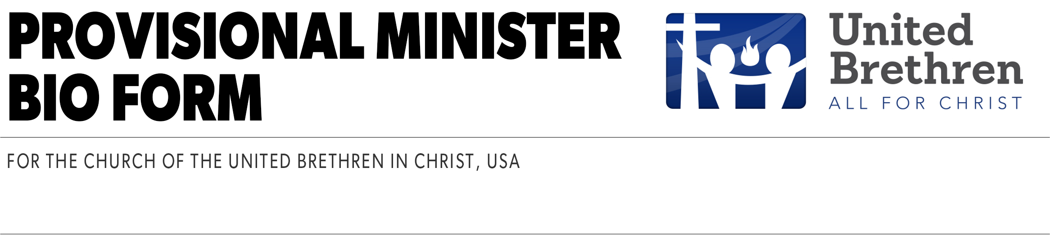

Full Legal Name
Full Preferred Name | Date

GENERAL INFORMATION
Male Female | Date of Birth:
Mailing Address:
City: | State: | Zip:
Home Phone: | Office: | Cell:
FAX: | Email:
Marital Status (check one)  Married Single  Engaged Divorced  Separated Widowed | If applicable:  Spouse's Name:  Anniversary: (m/d/yr)  Spouse’s date of birth: (m/d/yr)
Is your spouse employed? No
Yes Part-time Fulltime

CHILDREN
 | Child’s Name | Age
1
2
3
4

YOUR EDUCATION
 | College | Major | Degree | Yr Grad.
1
2
3

SPOUSE’S EDUCATION
 | College | Major | Degree | Yr Grad.
1
2
3

CHURCH POSITIONS
What roles or volunteer positions have you held in the local church?
1
2
3
4

INFLUENCES
What authors and/or mentors have had the greatest influence upon your life and thought? (List up to four.)
1.
2.
3.
4.

GIFTS, ABILITIES, AND INTERESTS
From this list, choose up to five which fit your strengths and interest. Rank them from one to five, 1 being the highest.
Counselor. A relationship which involves bringing comfort and encouragement to lonely, troubled, and sick persons and working with people to help them resolve problems primarily of a personal or family nature. May include nurture, healing, and guiding.
Administrator. Planning, promoting, and processing church-related ministries.
Teacher. Teaching in the church’s Christian education program. Involves the effective communication of biblical truth and asking application to everyday life.
Scholar. Activities involving teaching at a theological school or the college level, and engaging in scholarly research or writing.
Evangelist. Active commitment to leading people to faith in Christ.
Spiritual Guide. Facilitate experiences to nurture Christians in developing a more mature faith.
Preacher. Biblical exegesis, preparation and delivery of sermons that are relevant to the congregation.
Reformer. Activities that involve speaking out against evil and social injustice, and participating in programs of community enrichment.
Musician. Capable of leading a music program for a church.
Worship leader. Planning for worship and leading the congregation in celebration.

Other Skills. What other special skills do you have that could be used in your ministry and service? (Some examples might be landscaping, painting, technology, automotive, etc.)

LEADERSHIP QUALITIES
Evaluate yourself in the following 13 areas. Circle a number on the continuum to register your personal assessment (1 is weak, 5 is average, 10 is strong).
1. Visionizing. The ability to build something from nothing, to turn a vision into a reality, to develop a blueprint and turn it into a building.
1 2 3 4 5 6 7 8 9 10
2. Intrinsically Motivated. The ability to work from the “inside out” even when no one watches. Self-motivated.
1 2 3 4 5 6 7 8 9 10
3. Creates Ownership of Ministry. The ability to help people into a vision and move with it.
1 2 3 4 5 6 7 8 9 10
4. Relates to the Unchurched. The ability to relate freely to unchurched people and build a relationship bridge toward Christ and the church.
1 2 3 4 5 6 7 8 9 10
5. Spousal Cooperation. The ability to create an effective agreement with spouse and children about ministry and family goals.
1 2 3 4 5 6 7 8 9 10
6. Effectiveness in Building Relationships. The ability to establish and maintain deep and wide relationships.
1 2 3 4 5 6 7 8 9 10
7. Commitment to Church Growth. The ability to grow a church numerically and spiritually.
1 2 3 4 5 6 7 8 9 10
8. Responsiveness to the Community. The ability to read and respond to the needs in the cultural landscape.
1 2 3 4 5 6 7 8 9 10
9. Use the Giftedness of Others. The ability to enable others to discover their giftedness and mobilize them into meaningful ministry.
1 2 3 4 5 6 7 8 9 10
10. Flexible and Adaptable. The ability to bend with negotiables, not break with non-negotiables, and do whatever it takes when necessary.
1 2 3 4 5 6 7 8 9 10
11. Build Group Cohesiveness. The ability to unify and resolve the various agendas of a group of people.
1 2 3 4 5 6 7 8 9 10
12. Resilience. The ability to bounce back.
1 2 3 4 5 6 7 8 9 10
13. Exercising Faith. The ability to both know and trust God first, church growth principles second.
1 2 3 4 5 6 7 8 9 10

