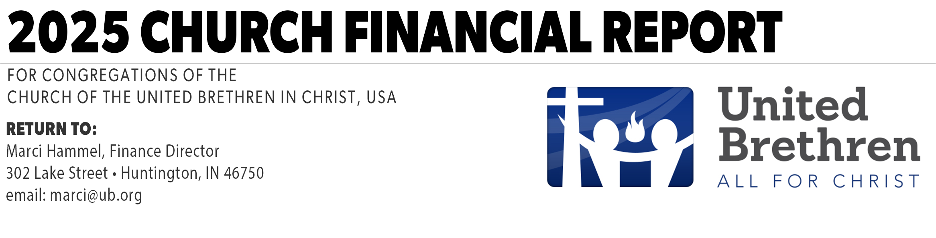
Local church treasurers should use this form to send the partnership fee to the UB national office. Payments are due by the 15th of the following month (Example: January payments are due by February 15). Use the TAB key to advance from one field to the next.

For the Month of
Church Name
Church City/State
Treasurer’s Name
Date Submitted

Fund |  |  | Amount
Partnership Fee |  | $
3.5% of total church income, minus missions giving, new construction, and estate gifts.
Defined Benefit Pension |  | $
Retirement Program Assessment |  | $
Other
Item 1 |  | $
Item 2 |  | $
Item 3 |  | $
Item 4 |  | $
Item 5 |  | $
Total |  | $

Send this form, along with your check, to Marci Hammel at the US National Conference Office.
Make checks payable to: United Brethren in Christ. If you have any questions, contact Marci Hammel. Email: marci@ub.org. Toll-free: 1-888-622-3019.

You will be asked to save this form as a new document. We suggest giving it a name which includes the month and year. For example: 2024_03Finances.doc. Make sure you include the “.doc” extension before sending it as an email attachment. Download it from: ub.org/finances

Revised 8/22/2023

