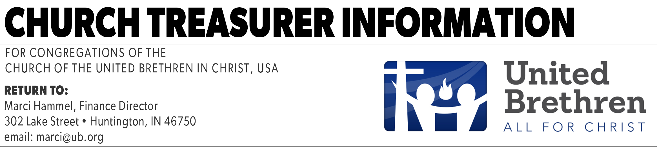

The United Brethren Finance Director needs contact information for each local church treasurer. A treasurer needs to complete and send this form only once. Please submit a new form whenever a new treasurer is appointed.

Use the TAB key to advance from one field to the next.

Treasurer Information
Treasurer’s Name:
Preferred Mailing Address:
City:
State:
Zip:
Email Address:
Phone Number:
Church Information
Church Name:
Church City:
Church State:
Date Completed:

You can send this to the Finance Director in several ways:
Email attachment: marci@ub.org
Ground mail: Marci Hammel, 302 Lake St., Huntington, IN 46750
FAX: 1-260-356-4730

(Revised 01/11/2021)

